Need of Studying Social Awareness Among Young
Individuals for Social Entrepreneurship:
Evidence from West Bengal
Uddalak Mukherjee, Kuntal Ghosh, Rabindranath Jana, Sanjoy Ganguly
March 13, 2025
Abstract
An apparently contrasting viewpoint in entrepreneurship is the term social entrepreneurship. While commercial entrepreneurship represents the identification, evaluation, and exploitation of opportunities that result in profits, social entrepreneurship, in contrast, refers to the identification, evaluation, and exploitation of opportunities that result in social value. In the context of social value, social entrepreneurship is crucial for teenagers as it fosters both understanding and informed decision-making in diverse social contexts, and helps them to develop their ability to be part of social movements often going beyond the realms of social entrepreneurship. International studies have examined social awareness and its components—such as gender, racial, religious, and political awareness—across various age groups, focusing primarily on race, gender, region, and sometimes education level. On a national scale, such studies have primarily undertaken in rural areas, examining social awareness directly or indirectly. Some studies show disparities in awareness across gender, caste, religion, region, and family status, while others claim no significant difference. Under this backdrop, the current researchers aim to study social awareness among the young people from different social aspects. Our study utilizes data collected through a survey by the Jana Sanskriti team under the Azim Premji Philanthropic Initiative, focusing on some areas of South 24 Parganas and Purulia districts of West Bengal due to prior rapport building there with the locals. Our findings suggest that there is disparity in social awareness among the youths across their gender, caste, region, age, and education, though no disparity across religion was detected. These outputs of the study will not only be useful from the perspective of social entrepreneurship, but also from the point of view of the policy-makers at any level. We recommend educating the groups with relatively low awareness, an effort that Jana Sanskriti(https://janasanskriti.org/) is advancing through the use of theatre and plays.
Key words: Commercial Entrepreneurship, Social Entrepreneurship, Social Awareness

1 Introduction
Entrepreneurship as stated by [1] is the core force of economic growth; the economic development which one experiences is just due the prevailing force of entrepreneurship. The entrepreneurship has many other types as well; it is divided on different traits and criteria, one of the criteria being Social. This type of entrepreneurship is very unique in nature and has different blends of components. The prime objective of social entrepreneurship stands different than the usual objectives of entrepreneurship; here social benefits are clubbed with economic benefits. Most of the times, social entrepreneurship is used in synonymous with social service/work. Social entrepreneurship as a practice that integrates economic and social value creation has a long heritage and a global presence [2]. The concept of social entrepreneurship means different things to different people and researchers [3]. One group of researchers refers to social entrepreneurship as not-for-profit initiatives in search of alternative funding strategies, or management schemes to create social value [4], [5]. A second group of researchers understands it as the socially responsible practice of commercial businesses engaged in cross sector partnerships [6], [7]. And a third group views social entrepreneurship as a means to alleviate social problems and catalyze social transformation [8].
Social entrepreneurship takes various forms based on its objectives. It includes the for-profit sector, where social-purpose ventures combine profit-making with addressing societal challenges [9],[10] (Dees & Anderson, 2003; Emerson & Twersky, 1996), and corporate social entrepreneurship, where businesses align social impact with strategic goals [4](Austin, Leonard, Reficco, & Wei-Skillern, 2004). The non-profit sector [3](Dees, 1998) focuses solely on social value creation, as seen in initiatives like Jana-Sanskriti . Additionally,(Dees, 1998)[3] hybrid models blend for-profit and non-profit approaches, addressing social needs while ensuring financial sustainability.
The social activities of Jana-Sanskriti align with the non-profit sector, focusing on social value creation. Before initiating social entrepreneurial activities in any area, it is essential to understand the local social dynamics, including fostering social awareness among youth, particularly those in high school and college. Social awareness involves not just meeting basic needs—such as food, water, shelter, healthcare, and education—but also enhancing intellectual capacities. It enables individuals to comprehend and empathize with others’ emotions, perspectives, and social cues, promoting meaningful interactions. Fostering social awareness among youth is crucial, as it encourages informed decision-making, enables participation in social movements beyond entrepreneurship, and equips them to contribute positively to their communities. This involvement strengthens social cohesion and personal growth, playing a vital role in the success of community-driven projects.
Awareness among people as stated by [11] plays an important role in carrying out their functions and adapting to live in multi-cultural contexts from their early age to the maturity. [12] studied the reality of social awareness and responsible decision making of grade 4 and 5 students in Vietnam and the correlation between these two. It deployed similar questionnaires with a 3-point Likert scale and performed One-Way ANOVA to examine the disparity in awareness levels by gender and residential area, and also used Pearson’s Correlation Coefficient to study the relationship between social awareness and responsible decision-making. The results indicated that the social awareness among individuals is average while responsible decision-making ability is slightly above average. Another study [13] delves into the political awareness among university students in post-apartheid South Africa. It utilized Ordinary Least Squares Regression to study the relationship between political awareness and off-campus political activity also studying the correlation between Off-Campus Political Participation and different other variables like sex, age, faculty of study and year of study. It found that the effect of political awareness was significant on off-campus political activity and the only variable with statistically significant effect on political awareness and off campus activity was year of study. Another study [14] examined the relationship between inter group dialogues and adolescents’ ethnic-racial identity and racism awareness using similar statistical tests like ANOVA and post-hoc tests. The findings indicated that there were statistically significant ethnic-racial group differences in ethnic-racial identity, but no group differences in racism awareness were found.
The study of social awareness among students has been approached from various an-gles in India. One notable study [15] conducted a gender-based comparative analysis of reading habits among undergraduate students, emphasizing the importance of systematic reading in intellectual and social development. This study utilized One-Way ANOVA to analyze the reading materials preferred by male and female students, aiming to uncover any gender disparities in reading habits eventually finding no significant difference among the two genders. Another significant contribution [16] explored students’ awareness of human rights education at the higher secondary school level, primarily employing qualitative methods and relying on descriptive analysis. A third relevant study [17] conducted a comparative analysis similar to the second paper but focused on gender differences in human rights awareness. A major study done in this field on West Ben-gal is [18]. Very similar to our study, it adopts a questionnaire feedback-based analysis technique with twenty questions on a five-point Likert scale with the options “Strongly Agree”, “Agree”, “Neutral”, “Disagree” and “Strongly Disagree” making up the questionnaire. The area of study for this paper was Purba Medinipur and the candidates were 100 school students. It utilized t-test and found disparity across different variables of study.
Existing literature shows that many similar studies in this domain, including those focused on West Bengal, often have limited sample sizes or lack quantitative depth. For instance, [18] had only 100 samples with 20 questions and did not perform normality tests to justify parametric methods. Additionally, the study involved only three variables, which did not fully utilize the sample data.
A more formal definition states: Social entrepreneurship is the innovative, social value creating activity that can occur within or across the nonprofit, business, or government sectors. Such social value, therefore, may have little to do with profits but may rather involve the fulfillment of the basic and long-standing needs such as providing food, water, shelter, medical services, and other social supports to those members of society who are in need, as also to enhance their intellectual capacities. The last mentioned is particularly important since the success of social entrepreneurship definitely depends on a team of dedicated individuals particularly belonging to the class of the deprived section who would have to be strongly socially aware. So, what is social awareness? It is the ability to comprehend and empathize with other’s; perspectives, emotions, and social cues, and to effectively apply this understanding in the interactions with them. This faculty is crucial for studying social awareness of teenagers as it fosters both understanding and informed decision-making in diverse social contexts, and helps them to develop their ability to be part of social movements often going beyond the realms of social entrepreneurship. It equips them to navigate and contribute positively to their communities, promoting social cohesion and personal development, thus contributing immensely to the society successfully.
The survey by Jana Sanskriti investigates combined awareness on caste-ism, patriarchy, and political dynamics in rural West Bengal’s South 24 Parganas and Purulia districts among adolescents aged 12 to 21. This area of study was chosen for our study because of prior rapport building and accessibility. The survey was conducted at the KKB Centre under the APPI project. Our paper investigates the impact of demographic and societal variables such as race, gender, region, and age on social awareness levels. Utilizing statistical tests on responses from 406 participants to a comprehensive 64-question survey (post pre-processing) across four categories (gender, caste, religion, and politics), we aim to provide a robust analysis. By examining seven key covariates, our study offers a rigorous assessment of disparities among different groups and sections.
2 Hypotheses

Hypothesis I (H0): There is no age disparity in social awareness with regard to all questions in the questionnaire.
Hypothesis II (H0): There is no gender disparity in social awareness with regard to all questions in the questionnaire.
Hypothesis III (H0): There is no disparity in social awareness across different blocks with regard to all questions in the questionnaire.
Hypothesis IV (H0): There is no district disparity in social awareness with regard to all questions in the questionnaire.
Hypothesis V (H0): There is no race disparity in social awareness with regard to all questions in the questionnaire.
Hypothesis VI (H0): There is no religious disparity in social awareness with regard to all questions in the questionnaire.
Hypothesis VII (H0): There is no educational disparity in social awareness with regard to all questions in the questionnaire.

3 Study Area and Data Collection
The area of South 24 Parganas and Purulia was chosen due to prior rapport building and high accessibility to the target population in the study areas.
The survey was developed based on extensive field experience and academic input from the Indian Statistical Institute. The Jana Sanskriti team, with over 40 years of field engagement, designed the survey to capture societal beliefs using a Likert-scale response format with options “not right at all”, “not right”, “don’t know” and “totally right”.
Participants independently completed the survey, with trained enumerators available for clarification. The survey had 458 respondents, ensuring a comprehensive representation of the population.
The survey was designed over one month and administered over two months in South 24 Parganas and Purulia through a structured questionnaire having 64 question items covering several social aspects and responses were graded on a scale from 1 (most negative) to 5 (most positive). Thus the study had covered 405 adolescents aged 12 to 21.
4 Analysis Technique

First, total scores for each candidate were calculated and standardized. Normality of the total score distribution was assessed using the Kolmogorov-Smirnov test and normality was confirmed. A deterministic technique was applied to categorize achievement level of the candidates into three groups / categories based on mean (μ) and standard deviation (σ) of their total scores: below average, average, and above average. Candidates with total scores below (μ – σ) were categorized as below average, those with scores between (μ – σ) and (μ + σ) were categorized as average, and those with scores above (μ + σ) were categorized as above average. Its theoretical aspects are depicted below (Figure 1).

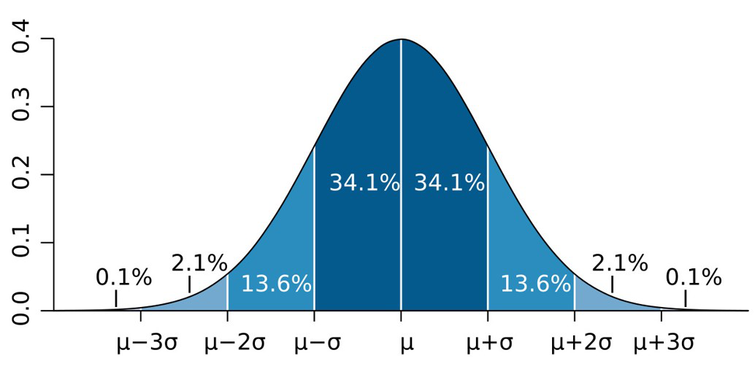
Figure 1: Normal Curve of Data

Under each categorical variable, the percentage of people in these three categories was observed.
Since, the total scores follow normal distribution, one-way ANOVA was used to test the hypotheses as mentioned above. Additionally, we tested for significant differences in question totals across blocks to look for significant difference in social awareness among different section of our study.
5 Results
5.1 Demographic Features of Survey
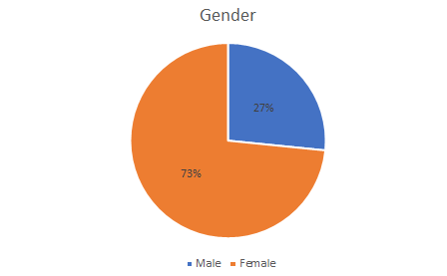
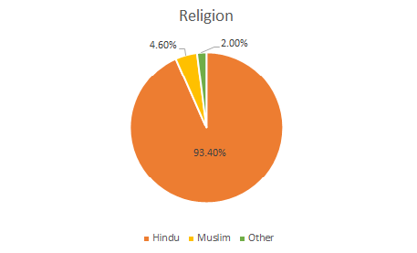
The gender composition reveals a majority of females (73.4%) compared to males (26.6%). This can be attributed to Jana Sanskriti’s predominantly female-oriented initiatives. Figure 2 also suggests it. The survey respondents are primarily from KKB, thus the gender participation rate in the children’s workshop is also mirrored in the analyzed data.

Figure 2: Gender And Religion Pie Charts

The collected data pertains to a religious composition, with 93.4% being Hindus, 4.6% Muslims, 2% belonging to other religions as illustrated in Figure 1, and a category of individuals who prefer not to disclose their religious affiliation.

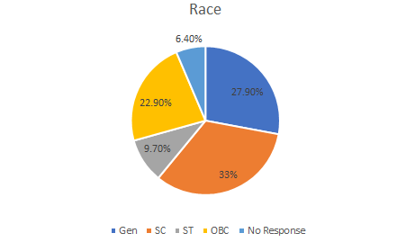
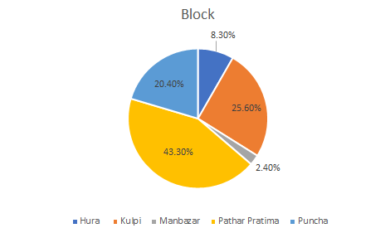

Figure 3: Region and Race Pie Charts
In terms of region, the data shows distribution as follows: Pathar Pratima - 43.3%, Kulpi - 25.6%, Puncha - 20.4%, Hura - 8.3%, and Manbazar - 2.4%. These regions are the primary areas of focus for Jana Sanskriti’s activities as illustrated in figure 3.

In the categorical breakdown of respondent castes, the distribution is as follows: SC -33%, General - 27.3%, OBC - 22.9%, ST - 9.7%, and 6.4% preferred not to respond. This diverse caste composition highlights the emphasis of Jana Sanskriti on inclusive participation from individuals belonging to various communities in their sessions. Once again it is demonstrated by figure 3.
We have examined the educational classes in which these respondents are enrolled, particularly within the context of KKB where the survey was conducted. KKB’s core emphasis lies in imparting diverse art forms to adolescents and children, with the aim of nurturing them into well-informed and conscientious citizens. As a result, the survey results reveal a significant majority of respondents falling within the educational range of classes 8 to 12. Most of the age group belongs to the 15-18 age category. The figure 4 demonstrates it.

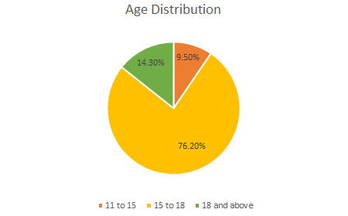

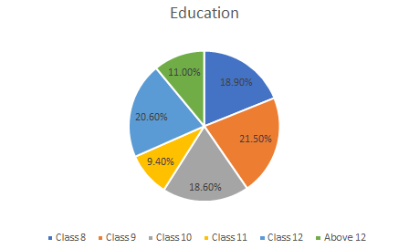

Figure 4: Age and Education Pie Charts

The survey inquiries revolve around four primary dimensions: caste, gender, religion, and political ideology. The distribution of questions is slightly varied, with caste and gender carrying greater significance, while religion and political ideology follow suit. The survey’s structure is thoughtfully crafted to comprehensively capture opinions across the dataset. We can refer to figure 5.

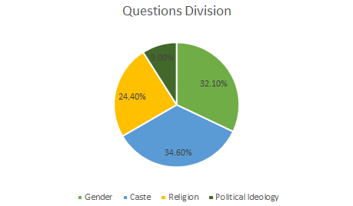
Figure 5: Questions Divisions Pie Chart

5.2 Achievement Level by Deterministic Approach
After cleaning the data, 404 candidates are finally considered for studying their awareness level on the basis of total score which approximately follows normal distribution (using normality test procedure Kolmogorov - Smirnov at level of 0.053) with estimated mean (μ = 217.69) and standard deviation (σ = 21.70). On total score, all the candidates have been categorized into three groups — below average, average, and above aver-age as described below:

1. Below Average: Candidates whose scores are below (μ – σ = 195.99)
2. Average: Candidates whose scores fall between (μ – σ= 195.99) and (μ + σ = 239.39).
3. Above Average: Candidates whose scores are above (μ + σ= 239.39).
Then, across the three categories, the percentage distributions are obtained by district, blocks, age, sex, religions, race and education (All tables in Appendix) from which the following findings are observed. It shows that when two districts combined, i.e., overall awareness level at neither below average (16.8%) nor above average (17.8%) is much, whereas majority (65.3%) is at average. When district-wise distribution is gone through, it illustrates that South 24 Parganas has a higher percentage of above average (21.4 %) and average (66.8 %) scores compared to Purulia (9.7 % and 62.1 % respectively). In case of block-wise distribution, it is observed that Pathar Pratima has the highest percentage of above average scores (22.6 %). Regarding religion, it indicates that Hindus and Muslims show different patterns in social awareness, with Muslims (30 %) having a higher percentage of above average scores compared to Hindus (17.2 %), though the sample size for Muslims is significantly smaller. The gender-wise distribution shows that females have a higher percentage of above average (20.9 %) and average scores (67.6 %) compared to males (9.3 % and 59.3 % respectively) in case of both districts, indicating higher social awareness among the females. The distribution by race shows that the General category has the highest percentage of above average scores (22.8%), while the SC/ST category has the highest percentage of below average scores (21.9%). When education level is considered, it reveals that candidates with education levels above higher secondary have the highest percentage of above average scores (38.1 %), while secondary level candidates have the highest percentage of below average scores (39.1 %). The age-category distribution indicates that adult candidates have the highest percentage of above average scores (28.7 %), while teen-aged candidates have the highest percentage of below average scores (18.4%).

5.3 Statistical Tests for Proposed Hypotheses
The following results are reported in correspondence to the independent samples ANOVA test that were performed to test all of the hypotheses.
Hypothesis I
The significance value for the age category was found to be very close to zero, being well below the 0.05 threshold. Therefore, the null hypothesis is rejected indicating significant difference in the social awareness levels across age groups. The average score for the adult category is 0.3316 while that of the teen aged child is -0.1087 with their standard deviations being extremely close to 1 implying that the adults have higher social awareness than the teen aged children as per the intuition. Due to insufficient data, individuals below the teenage category were excluded, resulting in a final sample size of 405 for this test.

Hypothesis II
The significance value for gender was also found to be close to zero implying rejection of the null hypothesis with indication that there is a significant gender disparity in social awareness.
The mean score for females is 0.1669, which is higher than the mean score for males, which is -0.4597, with both standard deviations being close to 1. Hence, females have a higher level of social awareness than males.

Hypothesis III
Just like the previous two cases, a very small significance value was observed for the blocks as well, thus indicating disparity in social awareness across different blocks with regard to all questions in the questionnaire.
Based solely on averages, Manbazar has the highest social awareness, but it only contributes 2 samples. More realistically, Pathar Pratima has the highest social awareness as it has the second highest mean score and the highest sample size at 177. On the other hand, Puncha has the lowest average score and a significantly large sample size at 89 indicating people living there has the lowest social awareness.
The Post Hoc Test (Tukey HSD) results reveal significant differences between certain pairs of blocks. Specifically, Pathar Pratima and Puncha show a significant difference with a p-value approximately zero. The comparison between Kulpi and Puncha also indicates a significant difference with a p-value of .001. Hence, our observation from the Post-Hoc test does indeed match with our initial observation.

Hypothesis IV
The test for social awareness disparity among districts yielded no different results. With the significance value being extremely small, we are once again compelled to reject the null hypothesis and admit the fact that there indeed is disparity among the districts.
The averages indicate that South 24 Parganas has a higher mean social awareness score (0.1472) compared to Purulia (-0.3303) with the standard deviations for both districts are close to 1. This suggests that respondents from South 24 Parganas have a higher level of social awareness than those from Purulia.

Hypothesis V
For race, the significance value was slightly larger at .039, which is still less than the 0.05 threshold. Therefore, we reject the null hypothesis and admit that there is a significant disparity in social awareness across different racial categories.

Direct means suggest that the General Category has the highest social awareness with a mean score of 0.1831, while the SC/ST category has the lowest with a mean score of-0.1071. The standard deviations of all three groups are close to 1, and their sample sizes are all significant.
The Post Hoc Test (Tukey HSD) results reveal significant differences between certain pairs of racial categories. Specifically, there is a significant difference between the General category and the SC/ST category with a p-value of .033. The comparison between other pairs does not indicate significant differences.
From these results, we infer that the General category has the highest level of social awareness, while the SC/ST category has the lowest level of social awareness among the racial categories studied.

Hypothesis VI
In contrast to the previous tests, significance value for religion is observed at .868, which is greater than the 0.05 threshold. Therefore, we fail to reject the null hypothesis (H0): There is no disparity in social awareness across different religious categories with regard to all questions in the questionnaire. This indicates that there is no significant disparity in social awareness across different religious categories. However, it is important to note that the sample size for Hindus is 386, while that of Muslims is only 20. This disparity in sample sizes may affect the reliability of the results, and further investigation with a more balanced sample size might be necessary to draw more conclusive results.

Hypothesis VII
The null hypothesis for education level is rejected once again owing to the small magnitude of the significance value indicating significant disparity in social awareness across different education levels.
Based on the Post Hoc test results, we can infer the following: - Students with education levels “Above Higher Secondary” have the highest social awareness, with mean differences being significantly higher compared to other education levels. “ Pre-Secondary” students have the lowest social awareness.
This suggests that higher education levels are associated with higher social awareness among the respondents.

6 Discussion and Conclusion
[18] suggested that there is no significant disparity in social awareness across gender, stream of study (arts or science), and family status (joint or nuclear) in the Purba Medinipur district of West Bengal. However, our study claims that such differences, especially when it comes to gender, are present in the chosen regions of study from South 24 Parganas and Purulia. Their study also suggested that awareness levels among both genders are generally healthy. Both these observations could be supported by the fact that the general literacy rate as well as the male literacy rate in Purba Medinipur is much higher in comparison with both Purulia and South 24 Parganas.
Both the deterministic approach and the statistical tests revealed a significant difference in social awareness levels across several demographic categories, namely gender, race, age, education level, district, and block, with the sole exception of religion. Among the categories that exhibited significant differences, the groups demonstrating higher levels of social awareness were generally consistent with intuitive expectations. For instance, adults displayed greater awareness than adolescents, and individuals with higher educational attainment were more socially aware than those with lesser qualifications. Similarly, districts and blocks with a stronger legacy of literacy and welfare exhibited higher levels of social awareness compared to others. However, contrary to prevalent public perception, our statistical analysis did not indicate any significant difference in social awareness levels among the religious groups. This result may be attributable to imbalanced sample sizes across the religious categories; nevertheless, one should not dismiss the possibility that there may indeed be no substantial disparity in awareness levels among these populations.
Other studies like [17] and [16] found varying results with respect to gender, with [17] stating that the level of awareness about human rights among boys is slightly higher than that in girls, however, no such significant difference was found in [16], which measures awareness by reading habits. International studies like [13] and [14], based on South Africa and the USA respectively, did not find any significant difference among groups of gender or race in political or racial awareness. However, [13] did suggest that there is a significant difference across the year of study, meaning age and educational level do affect the level of awareness among individuals.
Social entrepreneurship is mostly in India confused with social work, hence it is unable to make a mark as an individual entity in India. This is starting of challenge for social entrepreneurship. However we consider social entrepreneurship to be a particularly exciting and fruitful research topic and it is our hope that this study and the corresponding initiatives will bring us a step closer toward legitimizing and inspiring social entrepreneurship as a means to create social and economic value and as a field of research. The outputs of the study will not only be useful from the perspective of social entrepreneurship, but also from the point of view of the policy-makers at any level. We recommend educating the groups with relatively low awareness, an effort that is advancing through the use of theatre and plays.
The results obtained from both the deterministic approach and statistical methods consistently indicate that the categorical variables significantly influence the social aware ness levels of the surveyed individuals, as measured through their standardized total scores. This agreement between methods reinforces the robustness of our findings.
Our analysis also reveals no significant disparity among the question blocks concerning social awareness. This suggests that there is no section of the study where relative awareness is alarmingly low, indicating a generally uniform level of social awareness across the different question categories.
We recommend targeting educational initiatives towards groups with relatively low awareness. Jana Sanskriti is actively working towards this goal through innovative approaches like theatre and plays, which can effectively convey messages and promote social awareness.

References
[1] Rawal, T., 2018. A study of Social Entrepreneurship in India. International Research Journal of Engineering and Technology, 5(01), pp.70-95.
[2] Mair, J. and Marti, I., 2006. Social entrepreneurship research: A source of explana-tion, prediction, and delight. Journal of world business, 41(1), pp.36-44.
[3] Dees, J.G., 1998. The Meaning of Social Entrepreneurship. Kauffman Foundation and Stanford University.
[4] Austin, J.E., Stevenson, H.H. and Wei-Skillern, J., 2003. Social entrepreneurship and commercial entrepreneurship: same, different, or both?. Division of Research, Harvard Business School.
[5] Boschee, J., 1995. Social Entrepreneurship: Never thought that profit and philan-thropy would go hand in hand?. Across the board, 32, pp.20-25.
[6] Sagawa, S. and Segal, E., 2000. Common interest, common good: Creating value through business and social sector partnerships. California management review, 42(2), pp.105-122.
[7] Waddock, S.A., 1988. Building successful social partnerships. MIT Sloan Manage-ment Review, 29(4), p.17.
[8] Alvord, S.H., Brown, L.D. and Letts, C.W., 2004. Social entrepreneurship and soci-etal transformation: An exploratory study. The journal of applied behavioral science, 40(3), pp.260-282.
[9] Dees, J.G. and Anderson, B.B. (2003) Sector-Bending: Blurring Lines between Non-profit and For-Profit. Society, 40, 16-27.
[10] Emerson, J. and Twersky, F. (1996) New Social Entrepreneurs: The Success, Chal-lenge, and Lessons of Non-Profit Enterprise Creation. The Roberts Foundation, San Francisco.

[11] Jones, DE, Greenberg, M and Crowley, M ; Early social-emotional functioning and public health: The relationship between kindergarten social competence and future wellness, American Journal of Public Health, e-View Ahead of Print, doi: 10.2105/AJPH.2015.302630
[12] Huynh S.V ; Social Awareness and Responsible Decision Making of Students in Grade 4 and 5 in Vietnam Journal of Education and Human Development December 2018, Vol. 7, No. 4, pp. 7-15
[13] Badaru, K. A. & Adu, E. O. (2021). The Political Awareness and Participation of University Students in post-Apartheid South Africa. Research in Social Sciences and Technology, 6(3), 1-24.
[14] Aldana, A., Rowley, S. J., Checkoway, B., & Richards-Schuster, K. (2012). Raising Ethnic-Racial Consciousness: The Relationship Between Intergroup Dialogues and Adolescents’ Ethnic-Racial Identity and Racism Awareness. Equity & Excellence in Education, 45(1), 120–137. https://doi.org/10.1080/10665684.2012.641863
[15] Ahmad S., Dar B.A., Lone J.A. ; Reading Habits and Attitudes of Undergraduate Students: A Gender Based Comparative Study of Government Degree College (Boys) and Government Degree College for Women, Anantnag (J&K) ; Library Philosophy and Practice (e-journal) (2019), 2351
[16] Binjha P.B.; Students’ Awareness of Human Rights Education at Higher Secondary School level; International Journal of Social Science And Human Research (2022), 4746-4749
[17] Begum D.; A comparative study on Perception of Human rights between male and female students at the undergraduate level.; Turkish Journal of Computer and Mathematics Education Vol.12 No.12 (2021), 3413-3416

[18] Bera A.,Ashutosh S. ; Study of Social Awareness among School Students in Purba
Medinipur District of West Bengal; Central Asian Journal Of Social Sciences And History
Volume: 04 Issue: 05 — May 2023 (ISSN: 2660-6836) (ISSN: 2660-6836)

Appendix
Block-wise Category Distribution
Table 1: Block * Category Crosstabulation
District | Block | Above Average | Average | Below Average | Total
Purulia | Hura | 3 (8.6%) | 28 (80.0%) | 4 (11.4%) | 35 (100%)
Purulia | Puncha | 9 (10.1%) | 49 (55.1%) | 31 (34.8%) | 89 (100%)
South 24 Parganas | Kulpi | 20 (19.4%) | 69 (67.0%) | 14 (13.6%) | 103 (100%)
South 24 Parganas | Pathar Pratima | 40 (22.6%) | 118 (66.7%) | 19 (10.7%) | 177 (100%)
Total |  | 72 (17.8%) | 264 (65.3%) | 68 (16.8%) | 404 (100%)
District-wise Category Distribution
Table 2: District * Category Crosstabulation
District | Above Average | Average | Below Average | Total
Purulia | 12 (9.7%) | 77 (62.1%) | 35 (28.2%) | 124 (100.0%)
South 24 Parganas | 60 (21.4%) | 187 (66.8%) | 33 (11.8%) | 280 (100.0%)
Total | 72 (17.8%) | 264 (65.2%) | 68 (16.8%) | 405 (100.0%)
Religion-wise Category Distribution
Table 3: Religion * Category Crosstabulation
Religion | Above Average | Average | Below Average | Total
Hindu | 66 (17.2%) | 253 (65.9%) | 65 (16.9%) | 384 (100%)
Muslim | 6 (30.0%) | 11 (55.0%) | 3 (15.0%) | 20 (100%)
Total | 72 (17.8%) | 264 (65.3%) | 68 (16.8%) | 404 (100%)

Gender-wise Category Distribution
Table 4: Gender * Category Crosstabulation
Gender | Above Average | Average | Below Average | Total
Female | 62 (20.9%) | 200 (67.6%) | 34 (11.5%) | 296 (100%)
Male | 10 (9.3%) | 64 (59.3%) | 34 (31.5%) | 108 (100%)
Total | 72 (17.8%) | 264 (65.3%) | 68 (16.8%) | 404 (100%)
Table 5: gender * category Crosstabulation (Purulia)
Gender | Above Average | Average | Below Average | Total
Female | 8 (9.9%) | 54 (66.7%) | 19 (23.5%) | 81 (100.0%)
Male | 4 (9.3%) | 23 (53.5%) | 16 (37.2%) | 43 (100.0%)
Total | 12 (9.7%) | 77 (62.1%) | 35 (28.2%) | 124 (100.0%)
Table 6: Gender * category Crosstabulation (south24parganas)
Gender | Above Average | Average | Below Average | Total
Female | 54 (25.1%) | 146 (67.9%) | 15 (7.0%) | 215 (100.0%)
Male | 6 (9.2%) | 41 (63.1%) | 18 (27.7%) | 65 (100.0%)
Total | 60 (21.4%) | 187 (66.8%) | 33 (11.8%) | 280 (100.0%)
Race-wise Category Distribution
Table 7: Race * Category Crosstabulation
Race | Above Average | Average | Below Average | Total
GEN | 29 (22.8%) | 85 (66.9%) | 13 (10.2%) | 127 (100%)
OBC | 19 (18.8%) | 66 (65.3%) | 16 (15.8%) | 101 (100%)
SC/ST | 24 (13.6%) | 113 (64.2%) | 39 (22.2%) | 176 (100%)
Total | 72 (17.8%) | 264 (65.3%) | 68 (16.8%) | 404 (100%)
Table 8: Race * category Crosstabulation (Purulia)
Race | Above Average | Average | Below Average | Total
GEN | 3 (17.6%) | 11 (64.7%) | 3 (17.6%) | 17 (100.0%)
OBC | 4 (12.9%) | 21 (67.7%) | 6 (19.4%) | 31 (100.0%)
SC/ST | 5 (6.6%) | 45 (59.2%) | 26 (34.2%) | 76 (100.0%)
Total | 12 (9.7%) | 77 (62.1%) | 35 (28.2%) | 124 (100.0%)

Table 9: Race * category Crosstabulation (south24parganas)
Race | Above Average | Average | Below Average | Total
GEN | 26 (23.6%) | 74 (67.3%) | 10 (9.1%) | 110 (100.0%)
OBC | 15 (21.4%) | 45 (64.3%) | 10 (14.3%) | 70 (100.0%)
SC/ST | 19 (19.0%) | 68 (68.0%) | 13 (13.0%) | 100 (100.0%)
Total | 60 (21.4%) | 187 (66.8%) | 33 (11.8%) | 280 (100.0%)

Education-wise Category Distribution
Table 10: Education * Category Crosstabulation
Class | Above Average | Average | Below Average | Total
Above HS | 18 (40.0%) | 23 (51.1%) | 4 (8.9%) | 45 (100%)
Higher Secondary | 25 (19.7%) | 88 (69.3%) | 14 (11.0%) | 127 (100%)
Secondary | 21 (12.8%) | 104 (63.4%) | 39 (23.8%) | 164 (100%)
Pre-secondary | 8 (11.8%) | 49 (72.1%) | 11 (16.2%) | 68 (100%)
Total | 72 (17.8%) | 264 (65.3%) | 68 (16.8%) | 404 (100%)

Table 11: Education * category Crosstabulation (Purulia)
Class | Above Average | Average | Below Average | Total
Above HS | 8 (38.1%) | 9 (42.9%) | 4 (19.0%) | 21 (100.0%)
Higher Secondary | 2 (4.4%) | 34 (75.6%) | 9 (20.0%) | 45 (100.0%)
Secondary | 2 (4.3%) | 26 (56.5%) | 18 (39.1%) | 46 (100.0%)
Presecondary | 0 (0.0%) | 8 (66.7%) | 4 (33.3%) | 12 (100.0%)
Total | 12 (9.7%) | 77 (62.1%) | 35 (28.2%) | 124 (100.0%)

Table 12: Education * category Crosstabulation (south24parganas)
Class | Above Average | Average | Below Average | Total
Above HS | 10 (41.7%) | 14 (58.3%) | 0 (0.0%) | 24 (100.0%)
Higher Secondary | 23 (28.0%) | 54 (65.9%) | 5 (6.1%) | 82 (100.0%)
Secondary | 19 (16.1%) | 78 (66.1%) | 21 (17.8%) | 118 (100.0%)
Presecondary | 8 (14.3%) | 41 (73.2%) | 7 (12.5%) | 56 (100.0%)
Total | 60 (21.4%) | 187 (66.8%) | 33 (11.8%) | 280 (100.0%)

Age-wise Category Distribution

Table 13: Age * Category Crosstabulation
Age | Above Average | Average | Below Average | Total
Adult | 27 (28.7%) | 56 (59.6%) | 11 (11.7%) | 94 (100%)
Teen-aged and Below | 45 (14.5%) | 208 (67.1%) | 57 (18.4%) | 310 (100%)
Total | 72 (17.8%) | 264 (65.3%) | 68 (16.8%) | 404 (100%)

Table 14: Age * category Crosstabulation (Purulia)
Age | Above Average AAverage | Average | Below Average | Total
Adult | 9 (20.9%) | 25 (58.1%) | 9 (20.9%) | 43 (100.0%)
Teen aged and below | 3 (3.7%) | 52 (64.2%) | 26 (32.1%) | 81 (100.0%)
Total | 12 (9.7%) | 77 (62.1%) | 35 (28.2%) | 124 (100.0%)

Table 15: Age * category Crosstabulation (south24parganas)
Age | Above Average AAAverageAverage | Average | Below Average | Total
Adult | 18 (35.3%) | 31 (60.8%) | 2 (3.9%) | 51 (100.0%)
Teen aged and below | 41 (17.9%) | 156 (68.4%) | 31 (13.6%) | 228 (100.0%)
Total | 60 (21.4%) | 187 (66.8%) | 33 (11.8%) | 280 (100.0%)

